

**AMERICAN INTERNATIONAL UNIVERSITY-BANGLADESH (AIUB)**

Faculty of Engineering

Bachelor of Science in Electrical and Electronic Engineering (EEE) BAE 2101: Computer Aided Design and Drafting

**Experiment # 01: Introduction to Engineering Drawing and Computer Aided Design & Drafting and Familiarization with AutoCAD software and its different features.**

**Objective:** To familiarize the students with the basic concepts of engineering drawing and computer aided design & drafting.

**Description:** AutoCAD is a software application for computer-aided design (CAD) and drafting. The software supports both 2D and 3D formats. The software is developed and sold by Autodesk, Inc

# Engineering Drawing

Engineering drawing is one kind of drawing used by the engineers and technologists. It is the communication medium between the various person involved in the design and manufacture of mechanical and electrical components, machines, building, bridges etc.

# Drafting instruments

The most common types of drafting instruments are as follows:

* Drawing board
* T-scale
* Set-square Scales
* Compasses
* Protractor
* Pencils and leads, Eraser
* Papers

# Size of Drawing papers

Drawing papers may vary in sizes depending on the type of designing required. Following table represents some of the standard metric paper sizes.

Table: Standard Metric Paper Size

|  |  |  |
| --- | --- | --- |
| Paper Size | Border Size (mm) | Overall Paper Size (mm) |
| A0 | 821 x 1159 | 841 x 1189 |
| A1 | 574 x 811 | 594 x 841 |
| A2 | 400 x 564 | 420 x 594 |
| A3 | 277 x 390 | 297 x 420 |
| A4 | 190 x 267 | 210 x 297 |

# Types of Lines

Different types are used in the engineering drawing depending on the applications. Following are the types of lines which are used in common practices. Different types of pencils or leads are to be used while drawing different types of lines.

* Visible line/Object line: To indicate all visible outlines of an object, it shows the shape of an object.



* Hidden line/Dashed line: To represent the hidden edge of an object.
* Center lines: To show the center lines of holes, pitch line.



* Extension line, dimension line and Leaders: To show the dimension of an object extension line, dimension line and leaders are used.



* Section lines: To indicate the cut portion of an object.
* Cutting plane line: To show the imaginary cutting of an object.



# Scale of drawings

Scale is the ratio of the linear dimension of an element of a machines part as represented in the original drawing to the real linear dimension of the same element of the machine part itself. The scale of drawings are of three categories. a) Full size, b) Enlargement scale and c) Reduction scale.

# Dimensioning

To manufacture a part, dimensioning plays a vital role. Engineering drawing without dimensioning is valueless. Dimensioning is essential in manufacturing a product with precision. Dimension are indicated on the drawings by arrowheads, extension line, dimension lines, leaders, figures, notes, symbols etc. to define the geometric characteristics such as, length, diameters, angles, locations etc.

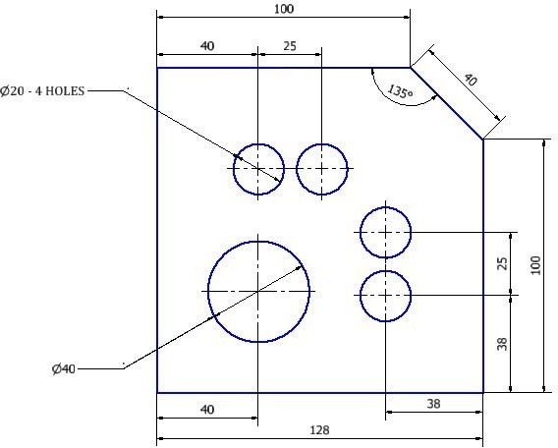

Figure 1: Example of dimensioning

# Projection

The purpose of engineering is to indicate the shape and size of an object. All objects have three dimensions (length, breadth and height). The exact shape of an object may be produced with the help of projection. Projection is the process in which the rays of sight taken in a particular direction from an object to form an image on a plane called plane of projection or picture plane. The image on the plane is called the view of the object. There are various types of projections, such as orthographic, oblique, perspective etc. depending on the direction of the rays of sight.

# Orthographic Projection

When the rays of sight are made in a perpendicular direction to the plane of projection, it is called orthographic projection. In the orthographic projection the observer stands in the infinite distance so that the rays of the sight appear to be parallel with each other. The perpendiculars, which are used to draw the view, are called the projectors. When a view is generated using perpendiculars from all the points of the object to the picture plane, it is called orthographic view.

# Types of Orthographic projections

Orthographic projection can be produced in four different angles (known as dihedral angles), which are formed by horizontal and vertical planes. The first and the third angles are used only for the projection.

# Difference Between First Angle and Third Angle Projection

First angle is used for the First angle projection while third angle is used for the Third angle projection. The difference of first and third angle projections is the relative positions of the observer, object and the picture plane. The object is positioned in the first quadrant for the first angle projection and in the third quadrant for the third angle projection. In the Third angle projection the picture plane is placed in between the object and the observer. On the other hand, in the First angle projection the object is placed in between the observer and the picture plane. In Bangladesh, usually the Third angle projection is used. They are also used in USA, Canada and many other countries. On the other hand First angle projection is used in many European and other countries. However, only the Third angle projection will be taken into consideration in this lab.

Third Angle projection: Observer – Picture plane – Object. First Angle projection: Observer – Object– Picture plane

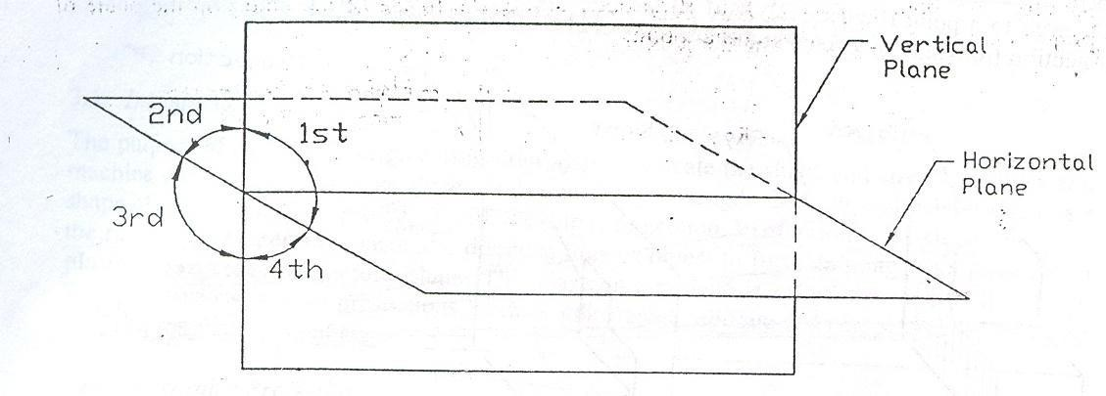

Figure 2: Four Different Angles

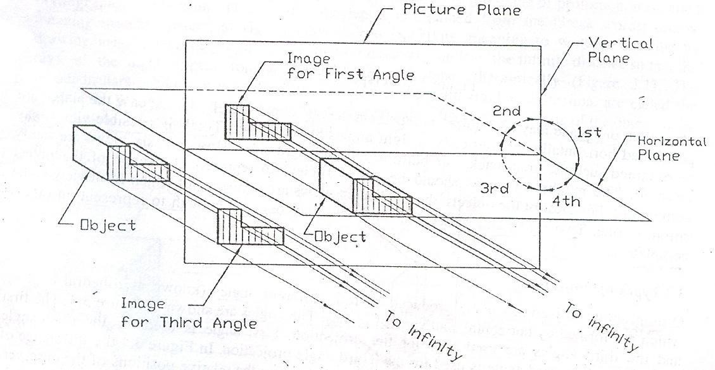

Figure 3: Difference between First and Third Angle Projection

# Third Angle Projection

The development of the Third angle projection has been illustrated in figures. A six-sided transparent box in the third angle projection has been shown. There are six sides but here only four sides are considered to represent the object. The projection plane upon which the front view is projected is called the Frontal plane (a-b-c-d plane) and the plane upon which the top view is projected is called the Horizontal plane (d-c-g-h plane); while the plane on which the side view is projected is called the profile plane (a-d-h-e plane).

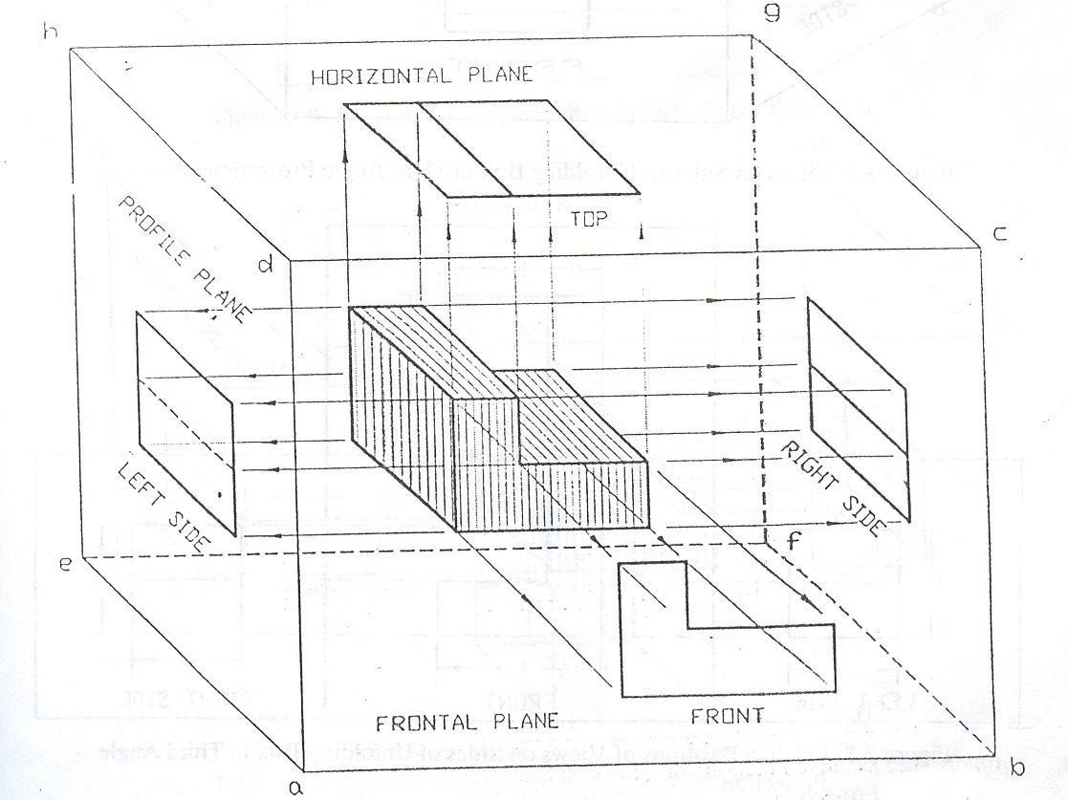

Figure 4: Third Angle Projection

The process of unfolding the box has been shown in figure. Here, the relative positions of the views on the sides of the unfolding box have been provided.

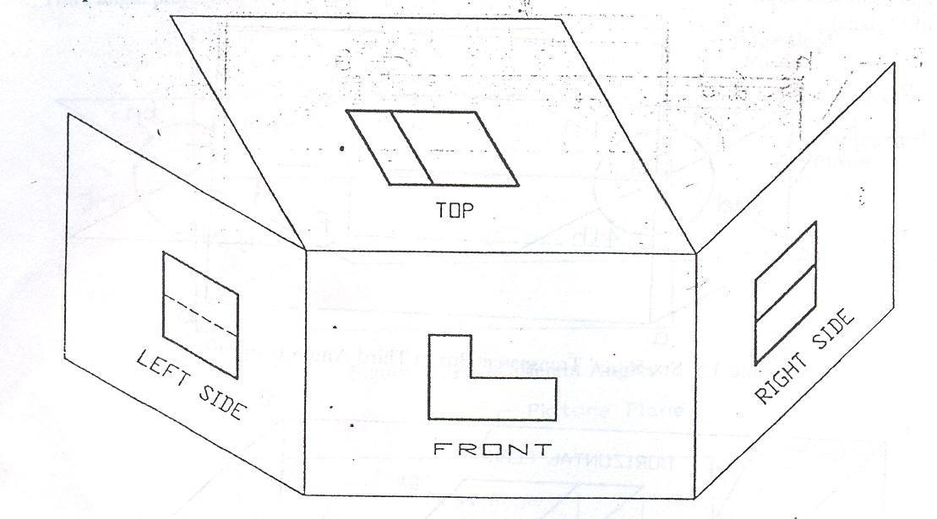

Figure 5: Sides of Unfolding Box in Third Angle Projection

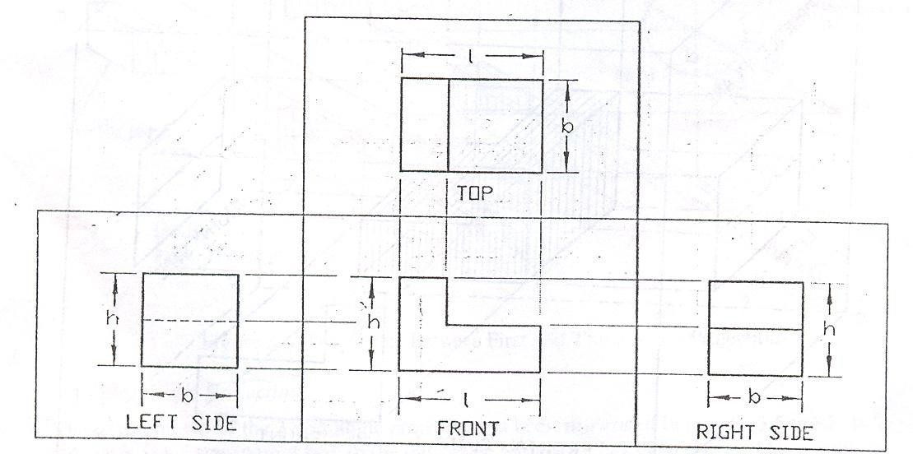

Figure 6: Relative Positions of Views on Sides of Unfolding Box in Third Angle Projection

# Isometric Projection

Isometric projection is the most common kind of projection used by engineers. It shows all three dimensions of an object which are useful to understand and visualize an object. To create an isometric projection, an object must be oriented so that its three principal edges (axes) make equal angles with the plane of projection and are foreshortened equally. For example, when a cube is oriented, it has equal angles of 120 degrees. The angles in the isometric projection are either 60 degrees or 120 degrees and are projections of a 90 degree angle.

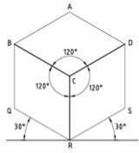

Figure 7: Isometric Projection

# Computer Aided Design and Drafting

The engineering drawing can be accomplished in computer software with much ease. It is possible to draw complex drawings, whether 2D or 3D, in computer using commercially available software tools. Computer Aided Design (CAD), with the help of computer system and a CAD software, helps the designer to create, modify, analyze engineering drawings. CAD improves the productivity of the designer, quality of the design and improve documentations procedures which facilitates manufacturing with higher precision. It is also possible to manufacturing directly obtaining the CAD file realizing into the manufacturing operations with proper dimension. Several CAD software tools are commercially available. Following are few CAD software widely used by the engineers for the drawing.

* AutoCAD
* SolidWorks
* Pro-Engineering
* CATIA
* AutoDesk Invntor
* TurboCAD

# Introducing AutoCAD

In this lab course, AutoCAD, created by AutoDesk Corporation, will be used. This software is the most widely used technical drawing program. People use this AutoCAD to generate different kinds of drawings. The major disciplines that used CAD are,

* Civil
* Mechanical
* Electrical/electronic
* Architecture
* GIS (Geographic Information Systems)
* Multimedia etc.

# Main parts of the AutoCAD window

1. **Title Bar** (Top bar)**:** Placed at the top of the window this shows the name of the program. The name of the current drawing appears in the Title Bar of the drawing area or document window.
2. **Menu Bar** (second top bar)**:** Located below the title bar. It contains the default AutoCAD menus. Menus are defined by menu files that can be modified.
3. **Toolbars:** A number of toolbars appear on the screen below the menu bar. Commands can be activated by clicking the buttons on the various toolbars. Appearance of various toolbars is optional, and their position can be shifted. The most common toolbars that appear by default include the following:
   1. Standard Toolbar (Undo, Redo, Zoom, Open, Save, Cut, Copy, Paste etc.
   2. Object properties Toolbars (Layer Toolbar and Properties Toolbar)
   3. Draw Toolbar (left bar)
   4. Modify Toolbar (right bar)
4. **Drawing Area:** The drawing area size varies, depending on the size of the AutoCAD window and on the number of other elements (such as toolbars and dialog boxes) that are displayed. This contains the following main features:
   1. Cursor (to locate points and select objects)
   2. User Co-ordinate System (UCS) Icon (displayed in the lower-left corner of the drawing area)
   3. Model Tab and Layout Tabs (use model space to draw the drawings and layouts to plot and print the drawings)
5. **Command Window:** Displays command prompts and command history. If anyone chooses commands from menu and toolbars, AutoCAD may display the command history in the command window.
6. **Status Bar** (bottom bar)**:** Displays the cursor co-ordinates in the lower-left corner. The status bar also contains buttons that you can use to turn on command drawing aids. These include:
   1. SNAP (F9)
   2. GRID (F7)
7. ORTHO (F8)
8. POLAR (F10)
9. OSNAP (F3)
10. OTRACK (F11)
11. LWT
12. MODEL

# Frequently used AutoCAD Features:

1. Drawing Units: Go Format Menu then Units
   1. Type – Engineering or Architectural, Unit- Inches
   2. Type – Decimal, Unit- milimeter.
2. Object Layers: Go Format Menu then Layer
3. Linetype: Format Menu then Linetype
4. Line weight: Format menu then Lineweight, Default lineweight 0.25mm or 0.01inch.
5. Object Snap Settings: move mouse on the OSNAP at the status bar then right click then settings.
6. Options: Tools menu then Options
7. File Save: Tools menu then Options then Open and Save
8. Text Style: Go Format Menu then Text Style
9. Dimension Style: Go Format Menu then Dimension Style
10. Object Properties: Tools menu then Properties or Modify menu then Properties
11. Viewports: View menu then Viewports

***Reference***

1. D[avid Byrnes](http://www.amazon.com/David-Byrnes/e/B001IGV37Y/ref%3Dntt_athr_dp_pel_1/181-5557732-0632033) and [Mark Middlebrook,](http://www.amazon.com/s/ref%3Dntt_athr_dp_sr_2/181-5557732-0632033?_encoding=UTF8&field-author=Mark%20Middlebrook&search-alias=books&sort=relevancerank) “AutoCAD 2007 For Dummies”.
2. Jeyapoovan T, “Lesson Plans for Engineering Graphics”.